Bet History iOS Developer Test

Task:

Using the my **mybets.json** file recreate the information layout in the design.

From the json you will be using the **singleBets** array. This contains a list of bets.

There is also an **opta** array which provides additional data on some of the bets. If present, cross reference the **optaId** from your **singleBet** to add the **timeElapsed** to your information.

A basic storyboard with tagged cells is already setup. The json file is local to the project.

Bonus Tasks:

Part of the code is under test

Refactor Table View Cell code

Style the UI

Guide:

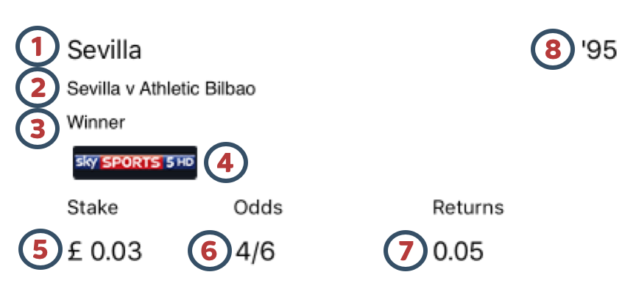

Json Reference:

1. singleBets[0].betDetails[0].betName
2. singleBets[0].betDetails[0].subeventName
3. singleBets[0].betDetails[0].marketName
4. singleBets[0].betDetails[0].broadcast.channelLogo
5. singleBets[0].totalBetStake
6. singleBets[0].betDetails[0].odds
7. singleBets[0].betDetails[0].potentialWinnings
8. opta[0].timeElapsed

Expected End Result

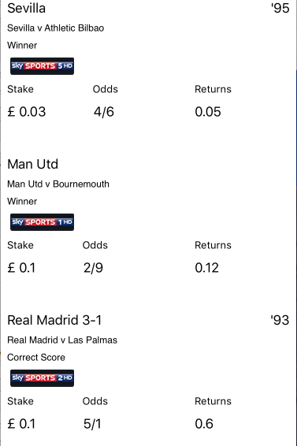

Good luck!